**1. SECTION – 1 : Cart-Service-Setup & Integration-Using-API-Gateway** 1

**2. SECTION – 2 : Payment-Service-Setup & Integration-Using-API-Gateway** 6

**3. SECTION – 3 : Call Cart and Payment Service API by UI** 7

**4. SECTION – 4 : Read Message by Azure Service Bus** 10

**5. SECTION – 5 : Implementation of SAGA Pattern** 19

**6. SECTION – 5.1 : Add RabbitMQ Configuration** 20

**7. SECTION – 5.2 : Define Stock Service Consumer** 21

# **1. SECTION – 1 : Cart-Service-Setup & Integration-Using-API-Gateway**

**Folder and File Structure:**

**Get Products from Database.**

1. Add CatalogService under FrontendServices > WebApp > HttpClients and ProductModel.cs, AddressModel.cs, CartItemModel.cs, CartModel.cs, PaymentConfirmModel.cs, PaymentModel.cs, RazorPayOrder.cs, TransactionModel.cs under Models Folder.
2. Add CatalogService service to the container in Program.cs file.
3. Home Controller call the CatalogService for Index action method to fetch products. Add a respective list view for the Index action method.
4. Add cart.js file under wwwroot > js folder. Add css under wwwroot > css > site.css.
5. Except SupportApp set all projects as start up projects.

**Add Cart to Database.**

1. Add CartService project (ASP.NET Core Web API) under BackendServices Folder.
2. Add Cart database name as **CartService29Jun** in database.
3. Create Database folder for AppDbContext under CartService project and right click > EF Core Power Tools > Reverse Engineer >

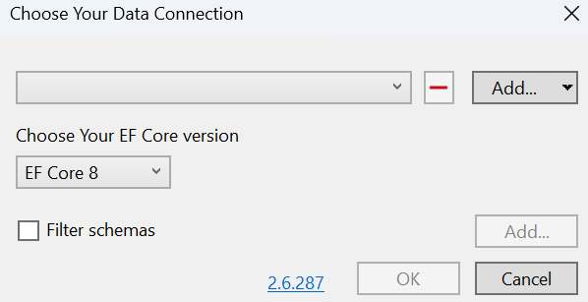

Add > Add Database Connection.

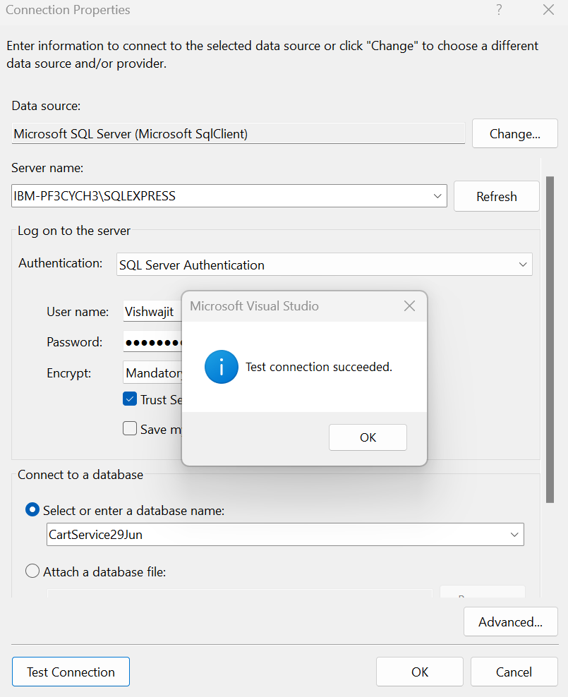

Ok >

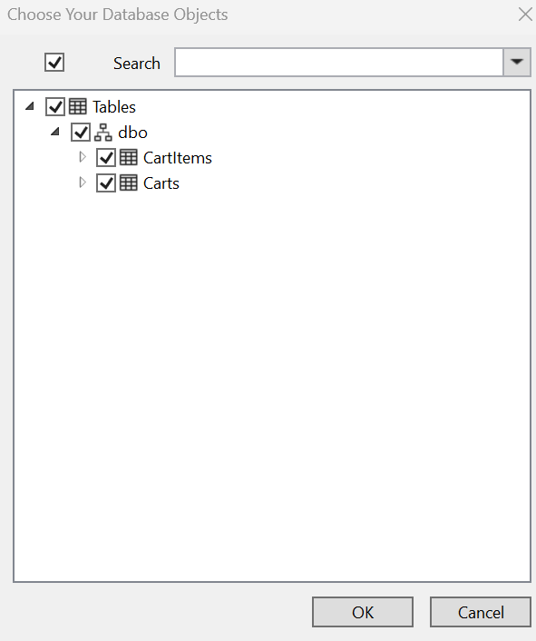

Ok >

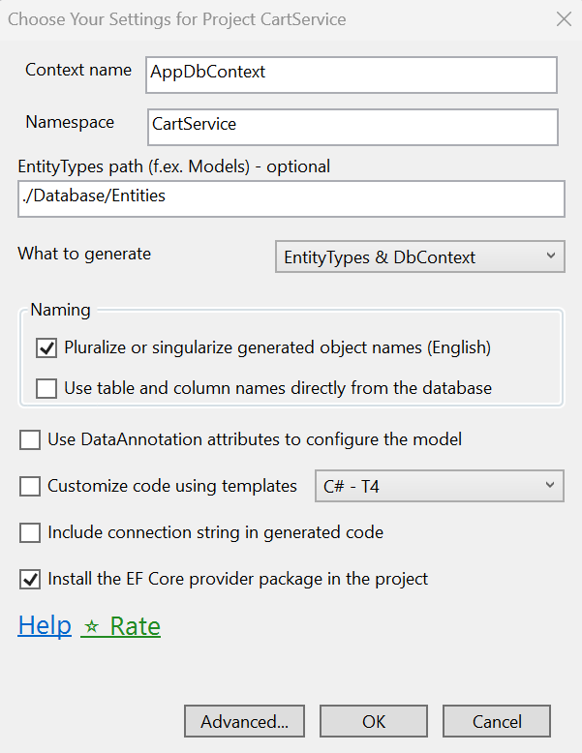

Advanced.. >

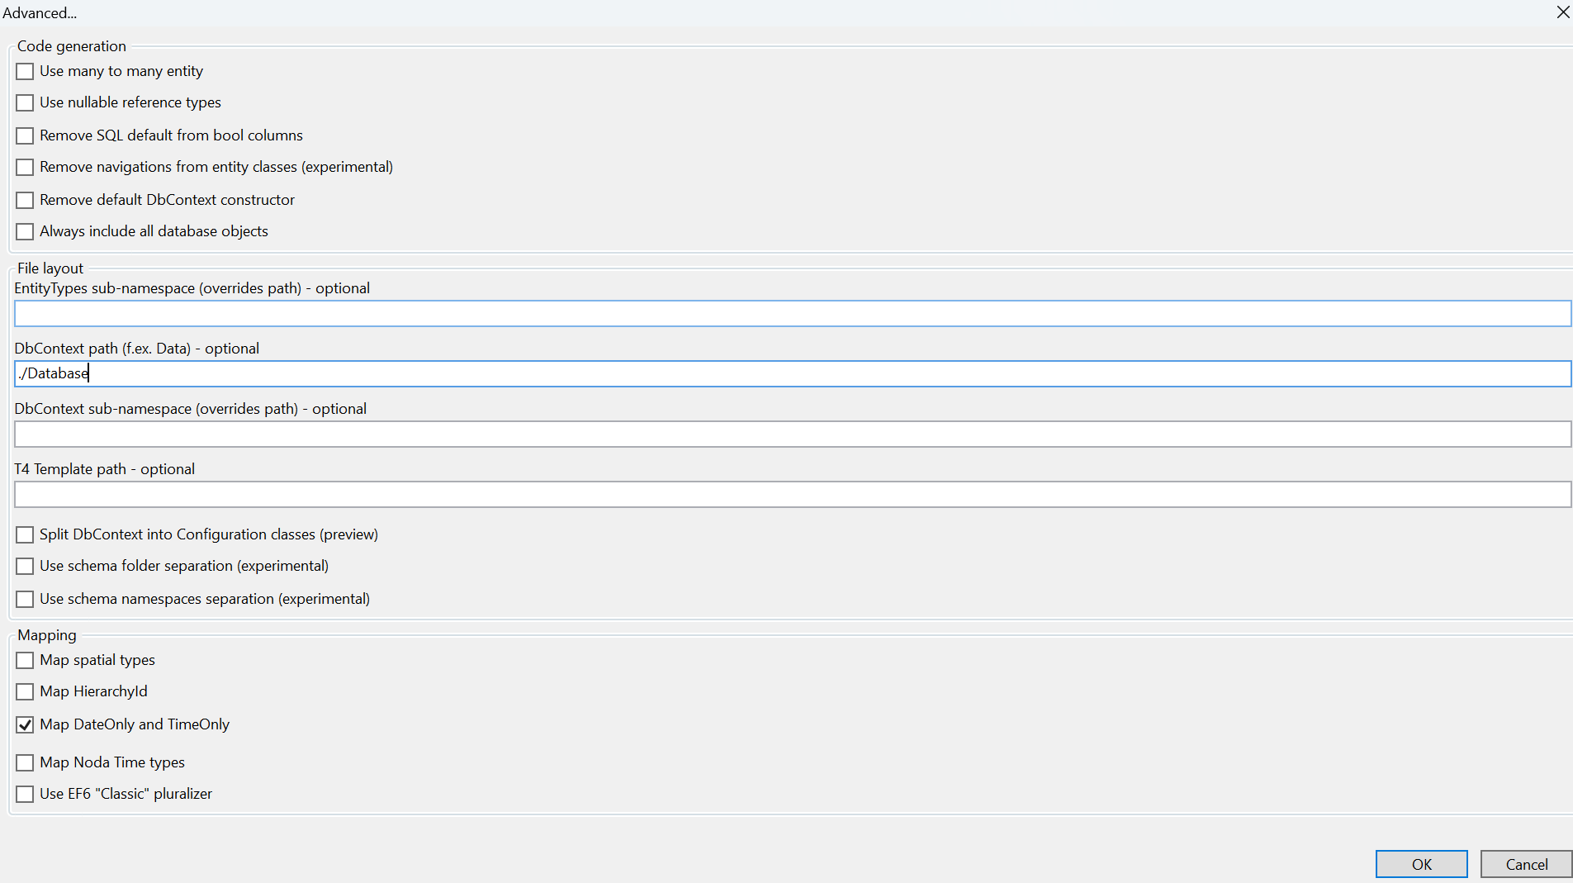

Ok

1. Add Models and Services (Repository) folder for Cart.
2. Add CatalogService under CartService Project > HttpClients
3. Define the connection string in appsettings.json file and add the Services to the container for database connection and serialization in Program.cs file.
4. Add a CartController in CartService Project and add API Gateway for CartService in ocelot.json. (Refer CartService https profile port – 7207. Same port refer in ocelot.json file for CartService gateway.

# **2. SECTION – 2 : Payment-Service-Setup & Integration-Using-API-Gateway**

1. Create PaymentService project (.NET Core Web API template).
2. Create a Database named as **PaymentService29Jun** and add table inside it. (Refer Script inside Database > Schema > Schema.sql )
3. Create AppDbContext using EF Core Power Tool as we did in the CartService. (But hereuse **PaymentService29Jun** database)
4. Add the below NuGet Package and Adding the services (Repository) and Models.

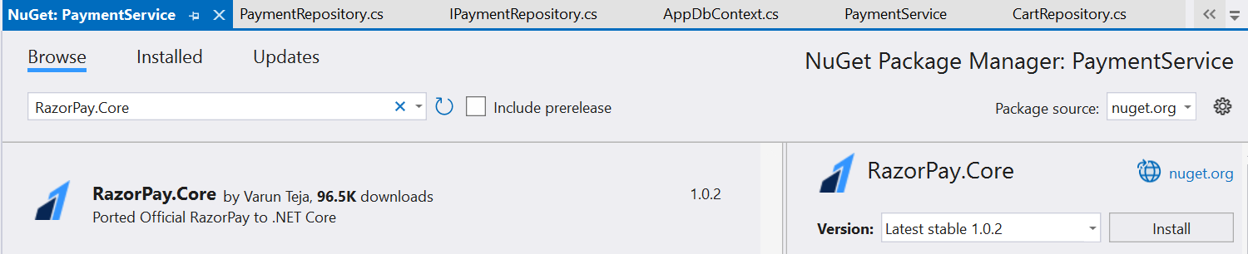

1. Add the connection string and RazorPay Key and Secret configuration in appsetting.json file

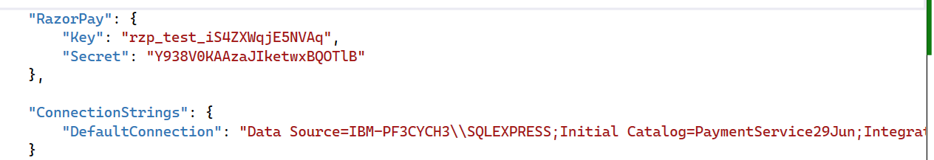

1. Add Services to the container for connection string,Scoped services and serialization in Program.cs file of PaymentService project.
2. Add a PaymentController.
3. Include a PaymentGateway in ocelot.json file

# **3. SECTION – 3 : Call Cart and Payment Service API by UI**

1. Create the PaymentService and CartService(http client) in FrontendServices > HttpClients to call the PaymentService , CartService and register the services in service to the container.
2. Add TempDataExtension in WebApp > Helpers folder and BaseController, CartController in WebApp > Controller folder.
3. Add a List page for Index action method of CartController.
4. Add a returnUrl parameter and its condition in Login Post action method of AccountController. Add the returnUrl parameter in Views > Account>Login.cshtml page.



1. Add the cart.js reference in Views > Shared > _Layout.cshtml file.
2. Add a view for CartController (CheckOut action method) of WebApp project.

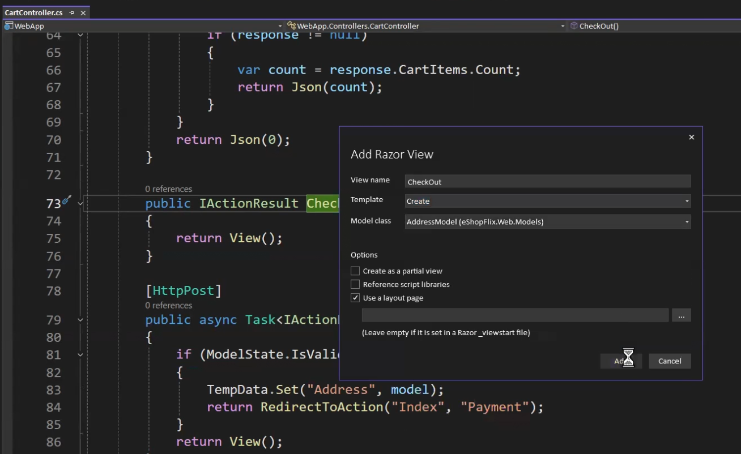

1. Except support App project, set all projects as startup project.
2. Add a PaymentController in WebApp project.
3. Ensure all the namespaces (WebApp.Models) imported in _ViewImports.cshtml file
4. Create View for PaymentController Index and Status action method.
5. Checkout the below links for Razorpay Web Integration Step for PaymentController Index view.

[Steps to integrate the Standard Checkout form on your website. | Razorpay Docs](https://razorpay.com/docs/payments/payment-gateway/web-integration/standard/integration-steps/)

1. Create View for PaymentController Receipt action method.
2. Add OrderController inside WebApp > Areas > User > Controllers. Add a View for its Index Action method.

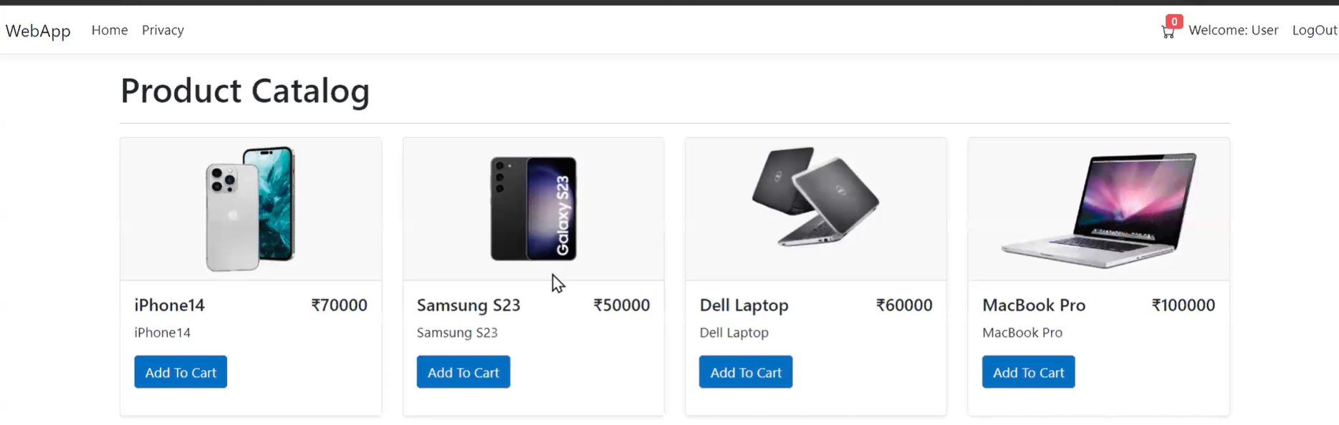

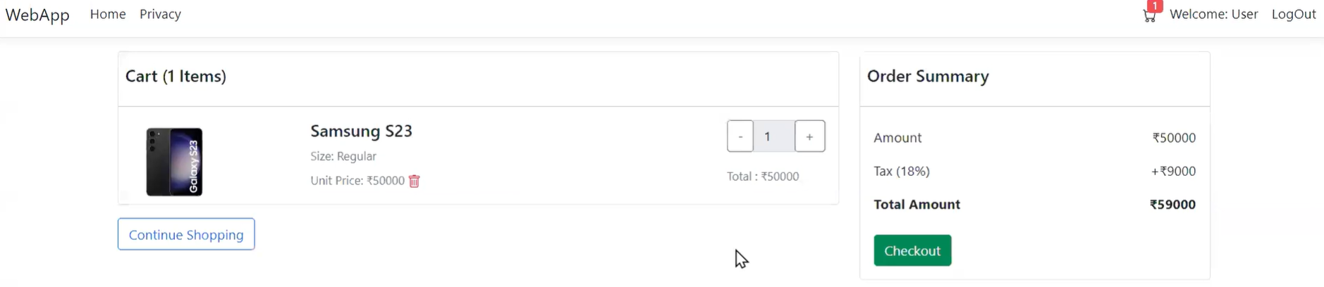

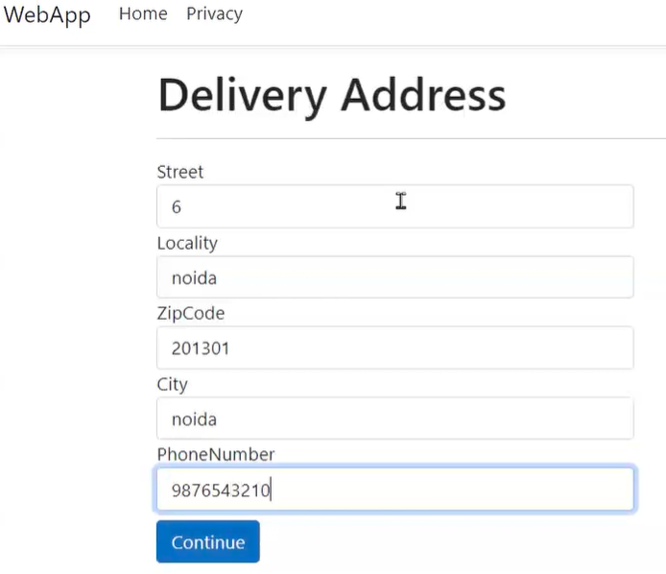

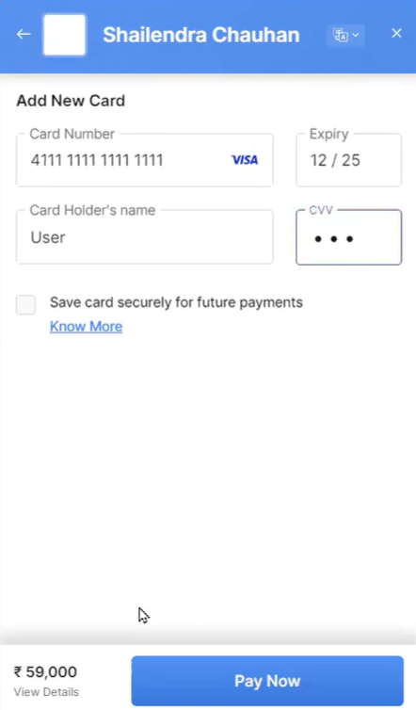

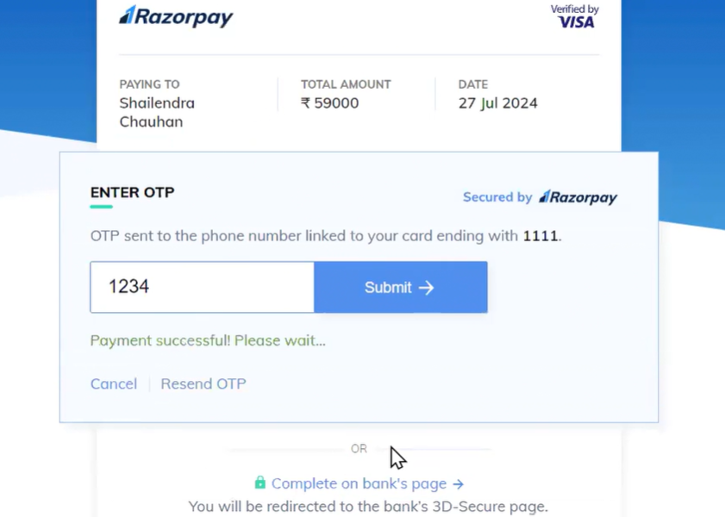

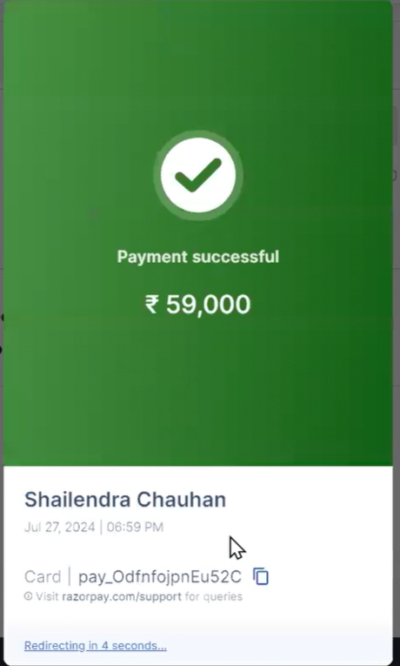

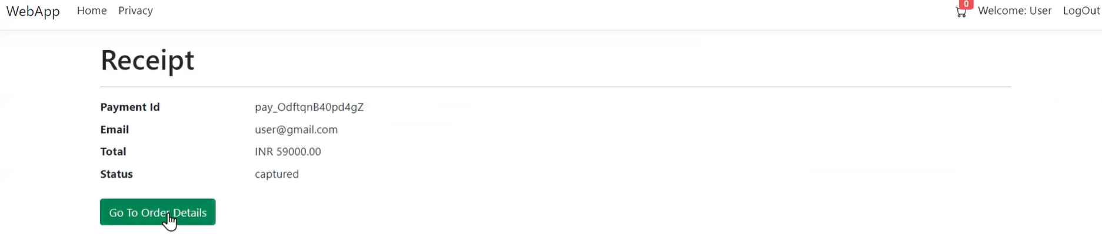

# **4. SECTION – 4 : Read Message by Azure Service Bus**

1. Go to <https://portal.azure.com> and login
2. Search the service bus resources.

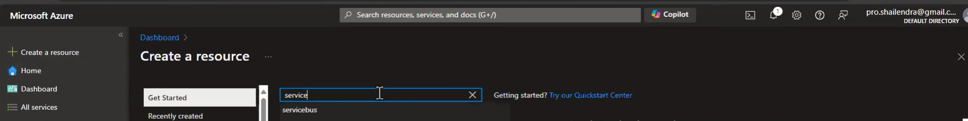

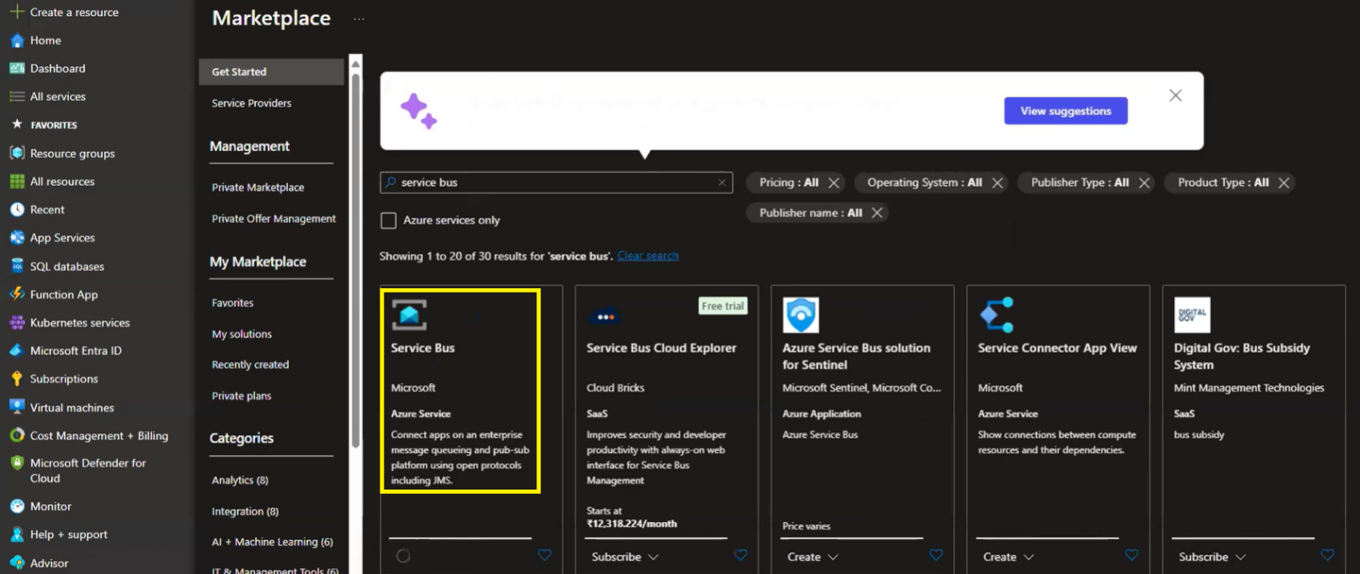

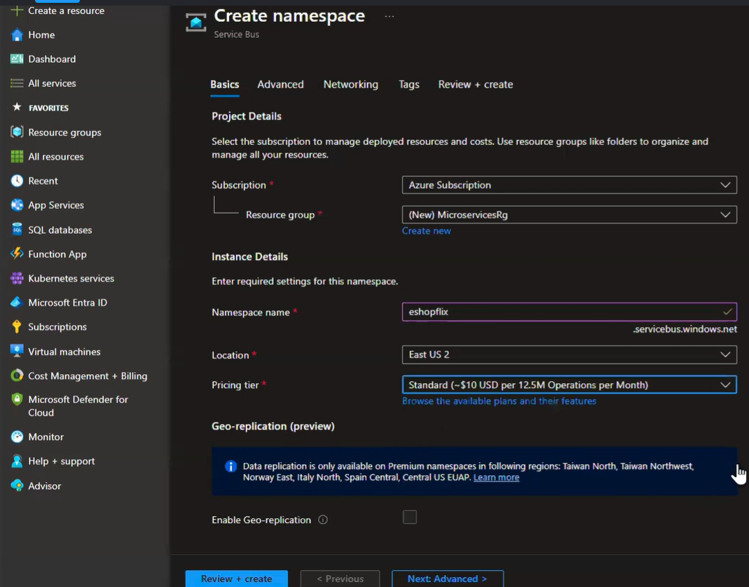

Next Advanced >

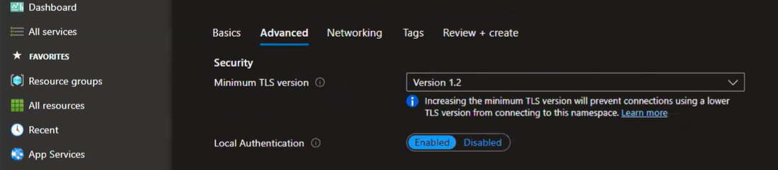

Next: Networking >

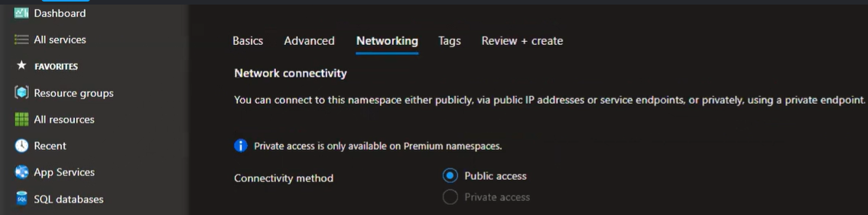

Next: Tags >

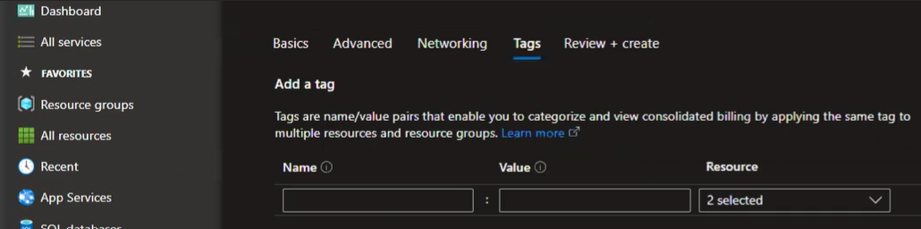

Next: Review + Create >

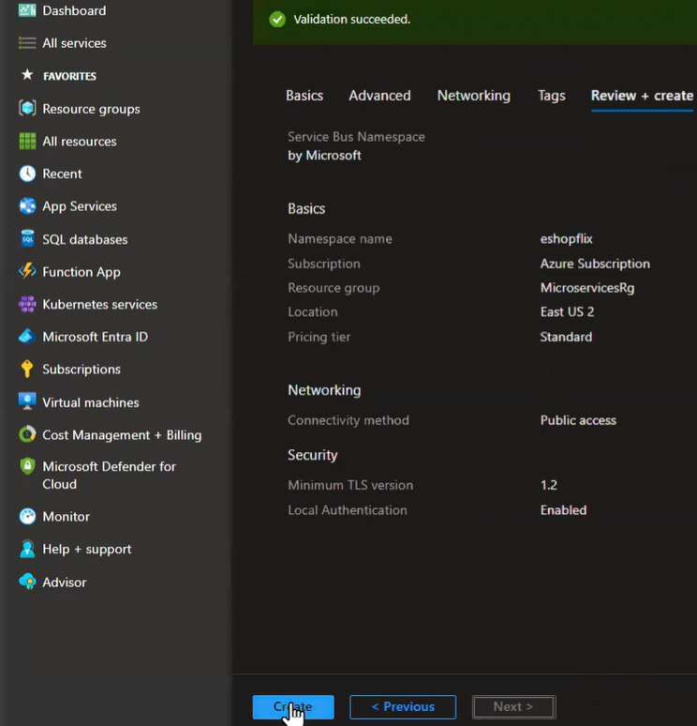

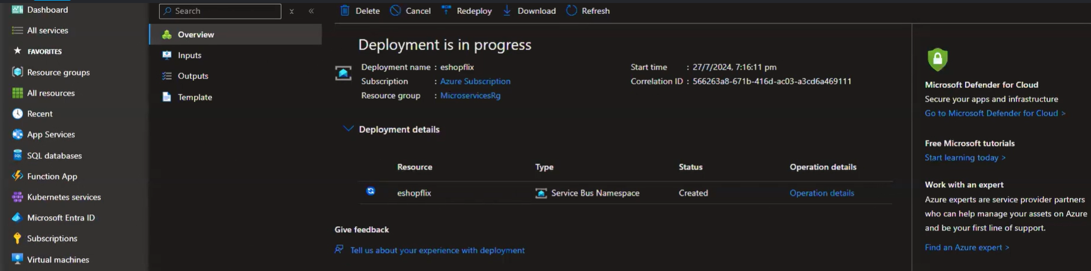

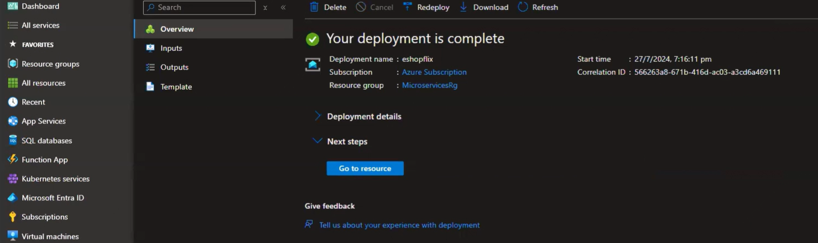

Go to resource >

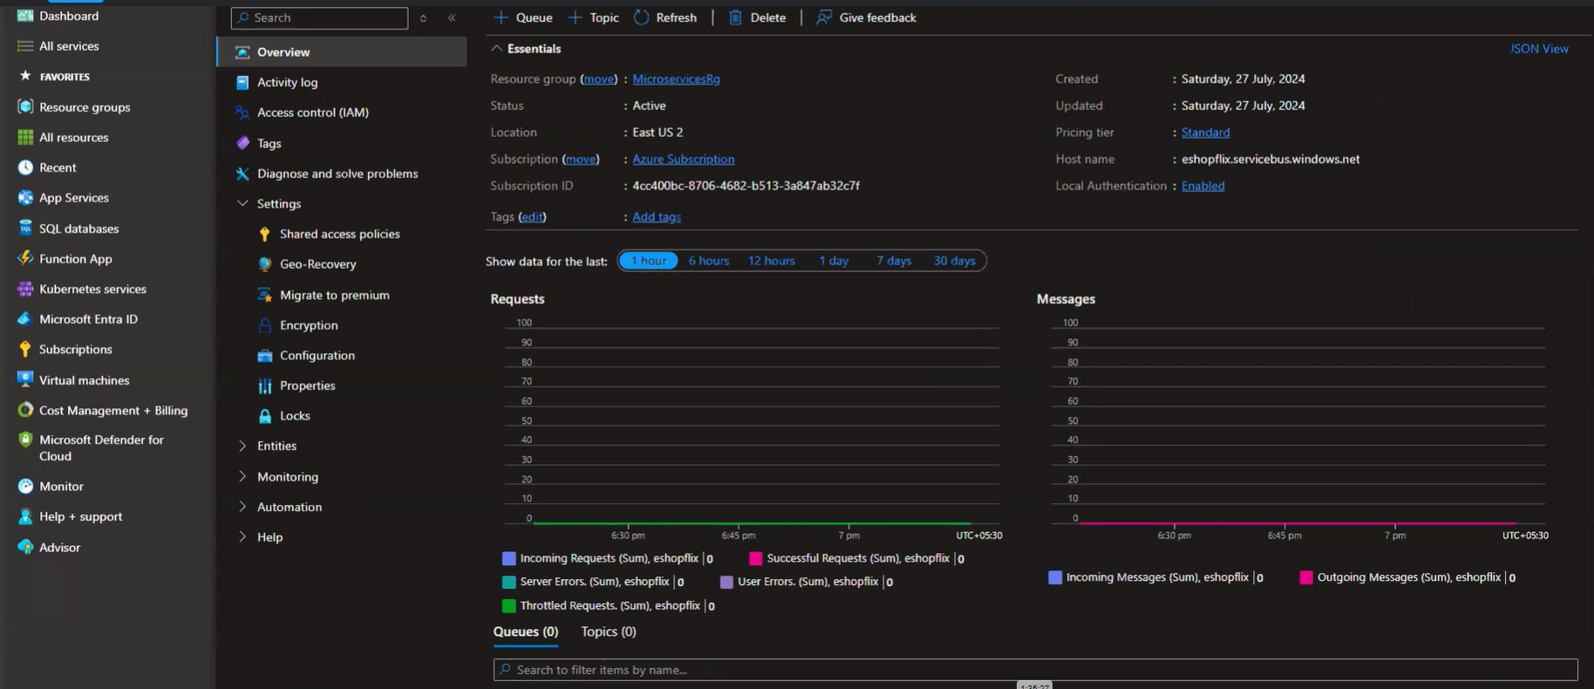

Add a Queue ( + Queue)

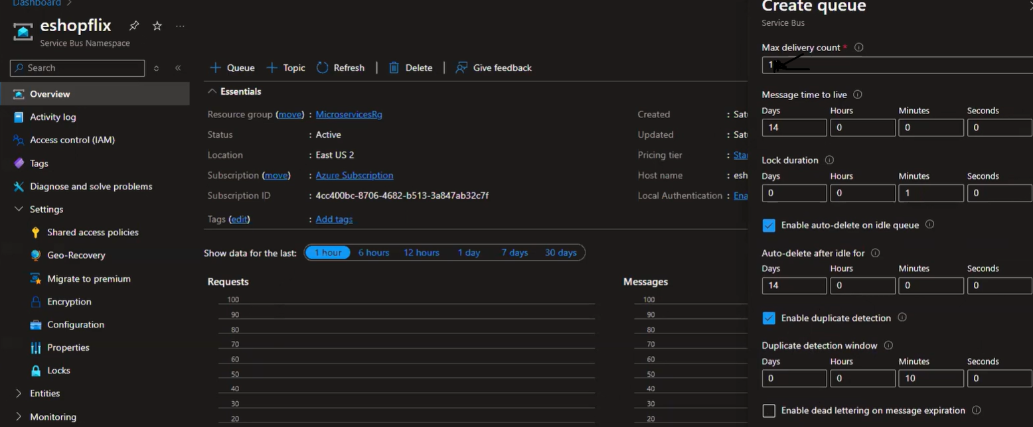

Create Queue >

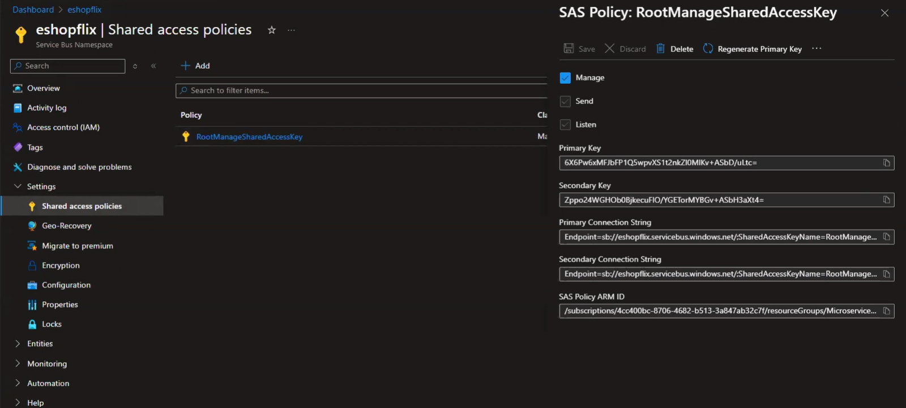

1. WebApp Project > appsettings.json > add the ConnectionString (Azure Service Bus) and ServiceBus (for OrderQueue) configuration.
2. Add below NeuGet Package

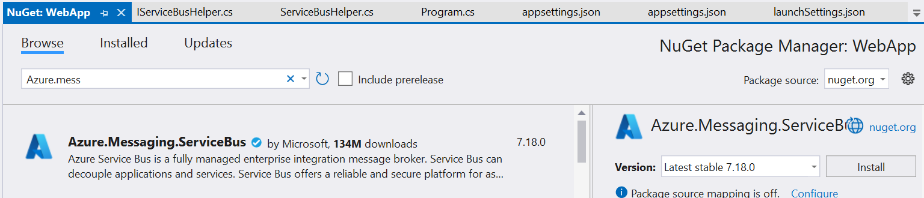

1. Add Message Folder inside WebApp and add OrderMessage.cs class.
2. Add IServiceBusHelper and ServiceBusHelper inside Helpers folder of WebApp Project
3. Uncomment the below code of WebApp project > PaymentController and its dependency injection code.

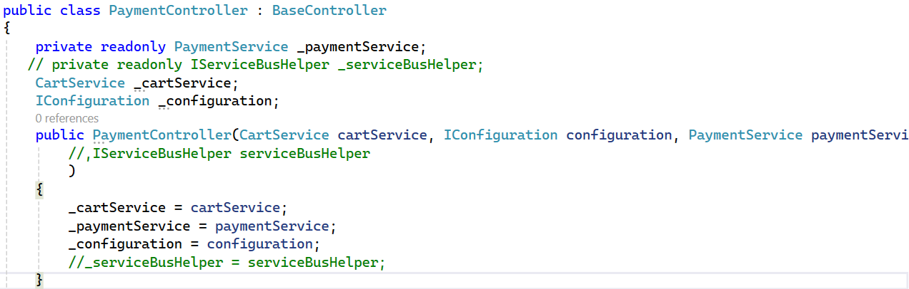

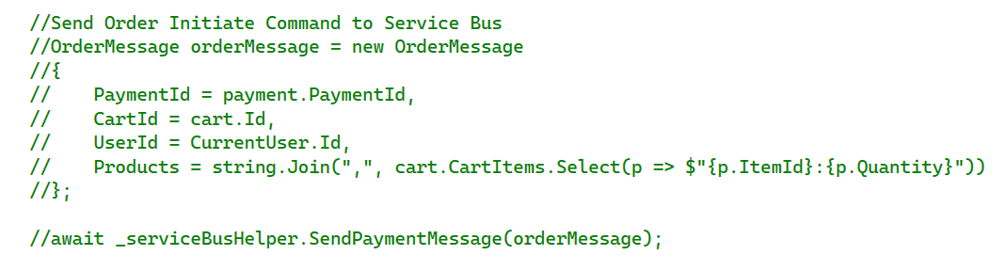

1. Add a services to the container.



1. Add a below NuGet Package inside the OrderService Project.



**<PackageReference Include="Microsoft.EntityFrameworkCore" Version="8.0.7" />**

**<PackageReference Include="Microsoft.EntityFrameworkCore.SqlServer" Version="8.0.7" />**

1. Add a Model folder inside OrderService > Model. Add OrderMessage.cs and CartItemModel.cs class. ( Same as we added in step 5 of WebApp Project)
2. Add a consumer in OrderService Project. Add a ServiceBus folder inside the Project.

Add IOrderConsumer and OrderConsumer inside ServiceBus folder.

1. Add a Connectionstring for local database , Service Bus connection , service bus and API address in OrderService project (launch setting https port of OrderService and CartService Project )

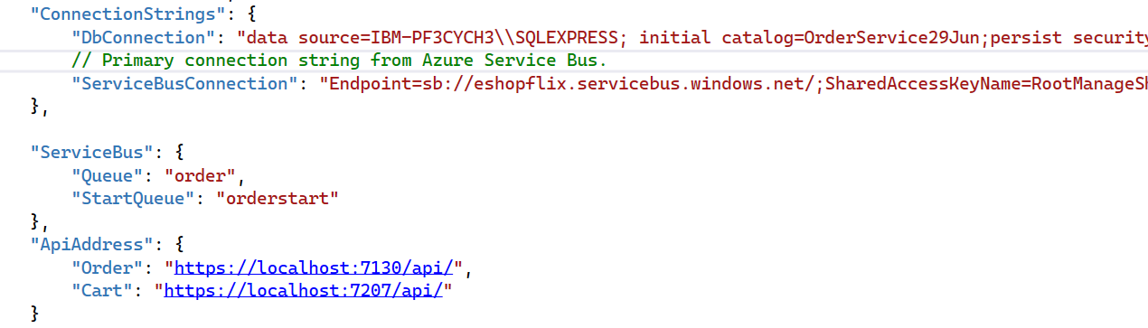

1. Create Database **OrderServiceJun29** and Execute the scripts (Database > SQL-Schema > SQLScript.sql) for **OrderServiceJun29** databaase and Add a AppDbContext using EF Core Power Tool wizard as we normally did the same way we have to do here also. (Take Only Order and OrderItem table. Exclude the OrderState table.)
2. Add HttpClient under OrderService > HttpClients > CartService.cs file.
3. Add Services to OrderService project.
4. Add services to the container in Program.cs file of OrderService Project.
5. Add a subscriber to listening the messages in Program.cs file of OrderService Project.



1. Create OrderController and its action method name as CreateOrder in OrderService Project to initiate the SAGA Pattern.
2. Except SupportApp, all the projects setup as start up projects.

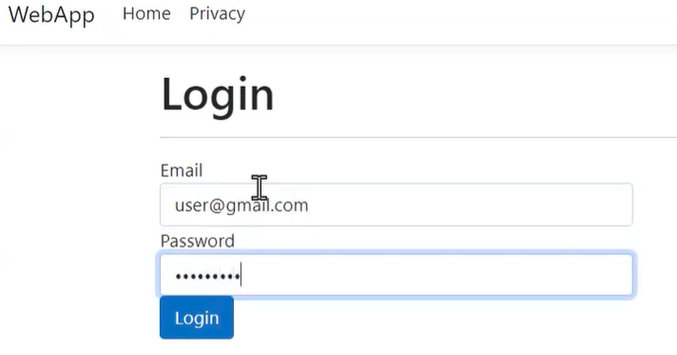

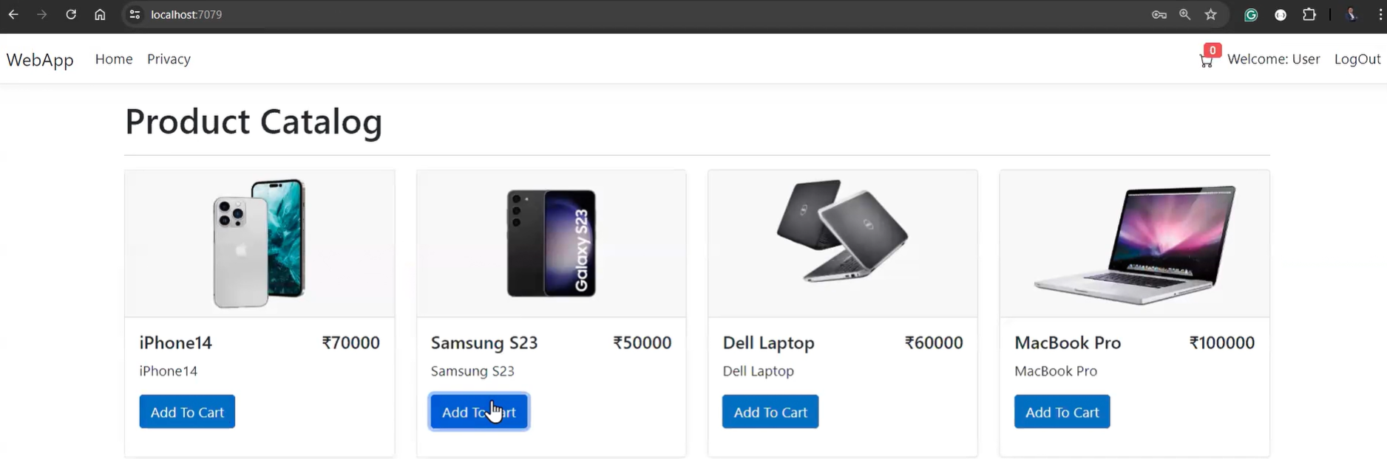

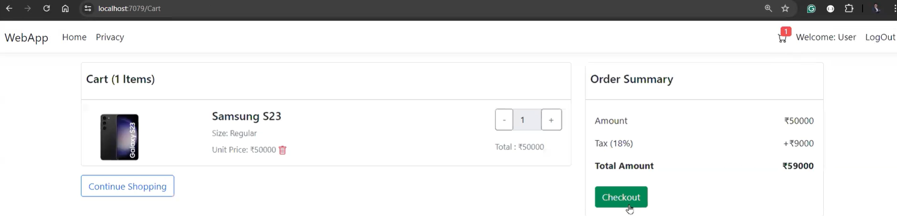

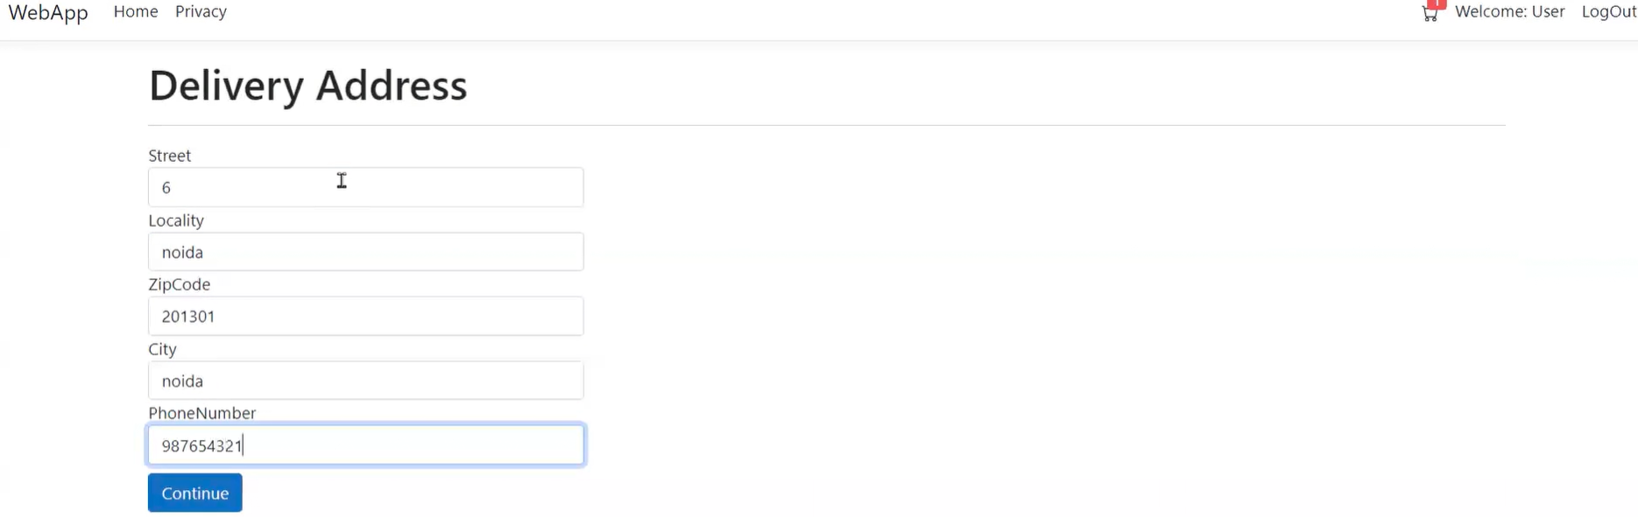

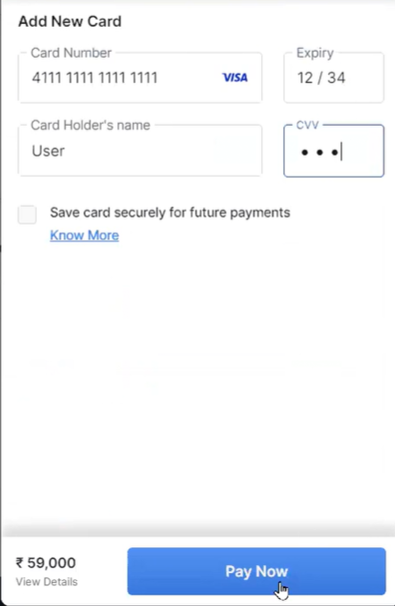 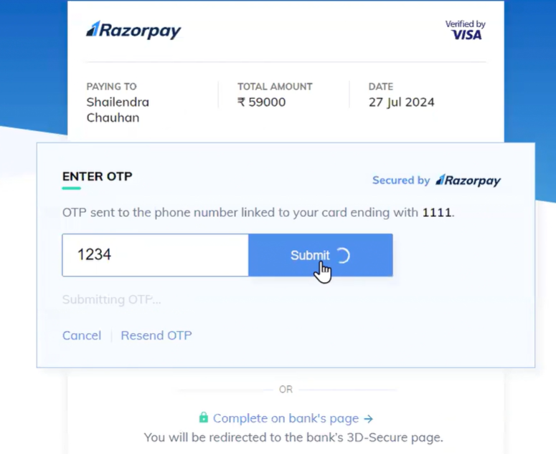

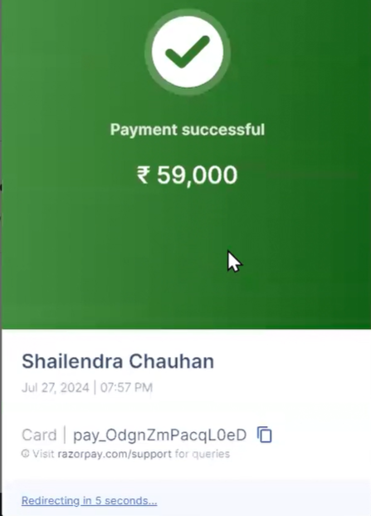

Flow

Call the PaymentController of Web App > WebApp > Call the SendPaymentMessage method of ServiceBusHelper > OrderServiceProject > ServiceBus >call the MessageHandler method of OrderConsumer.cs file > Call the CreateOrder action method of OrderController.

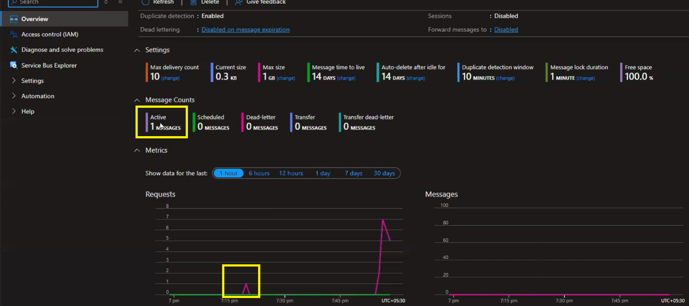

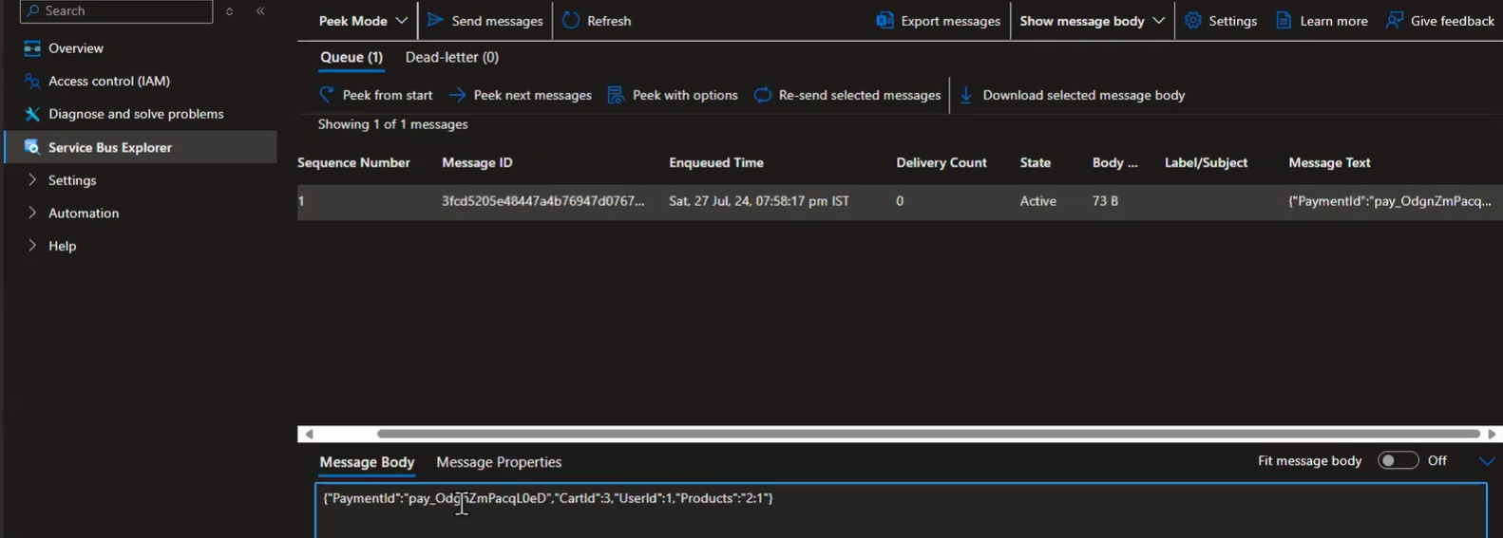

User login details => User Id : [user@gmail.com](mailto:user@gmail.com) Password : User@12345678

Admin login details => User Id : [admin@gmail.com](mailto:admin@gmail.com) Password : Admin@12345678

# **5. SECTION – 5 : Implementation of SAGA Pattern**

1. Run the docker command in command prompt for Rabbit MQ and check in docker desktop

**Reference for Saga Pattern**

[State Machine · MassTransit](https://masstransit.io/documentation/patterns/saga/state-machine)

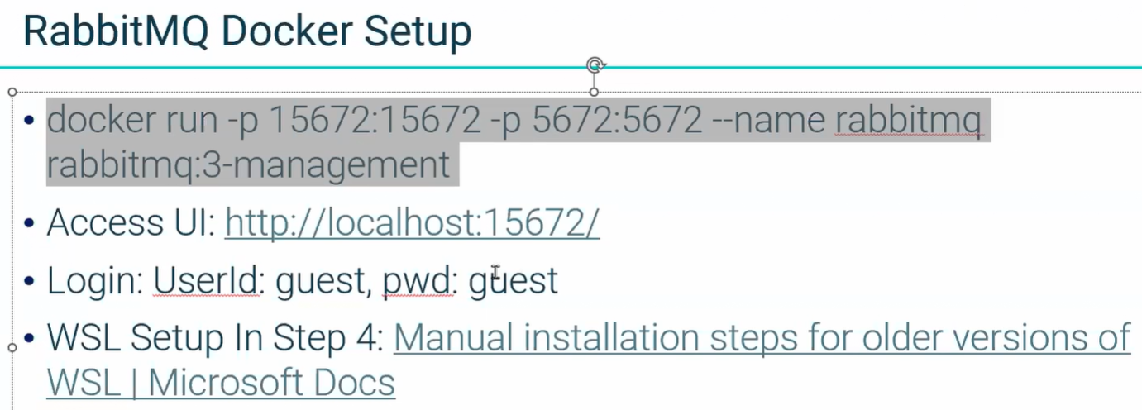



1. Create new project under BackendServices. Add > New Project > Class Library name it as CommonLibrary.
2. Create OrderStateContext for CommonLibrary using EF Core Power Tool wizard. This is not normal db context. Please check the file.
3. Install below MassTransit and EntityFrameworkCore packages.

<PackageReference Include="Microsoft.EntityFrameworkCore.SqlServer" Version="8.0.5" />

<PackageReference Include="MassTransit.Extensions.DependencyInjection" Version="7.3.1" />

<PackageReference Include="MassTransit.EntityFrameworkCore" Version="8.0.3" />

1. Add Message folder under that add two subfolder name Commands (To initiate the orders ) and Events
2. Add folder StateMachine and define the class OrderStateMachine ( To define the events)

# **6. SECTION – 5.1 : Add RabbitMQ Configuration**

1. In **5.Section -5** we use Azure Bus in OrderService Project. Now we use RabbitMQ instead of Azure Bus.
2. Add the below NuGet Package in OrderSerice Project.



1. Add **CommonLibrary** project reference in **OrderSerivce** Project. (Right click on Dependencies > Add Project Reference > select CommonLibrary project.)
2. Add the consumers in OrderService projects. Add Consumers folder > add the OrderStartConsumer.cs, OrderAcceptedConsumer.cs, OrderCancelledConsumer.cs. This consumers will run in background.
3. Configure RabbitMQ services to the conatiner in Program.cs file of OrderService Project. From Line No – 38
4. Add the SAGA Pattern code in OrderController of OrderService Project.

# **7. SECTION – 5.2 : Define Stock Service Consumer**

1. Create new StockService (ASP.NET Core Web API) Project under BackendServices.
2. Add StockController and Create Database **StockService29Jun.**
3. Add a AppDbContext using data base first approach using EF Core Power Tools.
4. Add a Services for a Database operations.
5. Add a Consumer in StockService project. Its give the response when we check for the Stock Validation purpose to check the stock availability or not. Add a reference of CommonLibrary project in it. It works as in background service.
6. Add the below packages in StockService Project.



1. Define a connection string , ServiceBus queue name, Mass Transit configuration in appsettings.json file of StockService.